Westminster Abbey Reflection
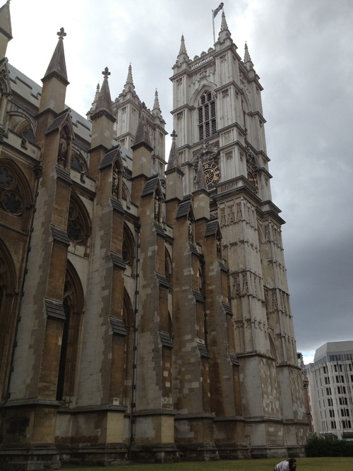
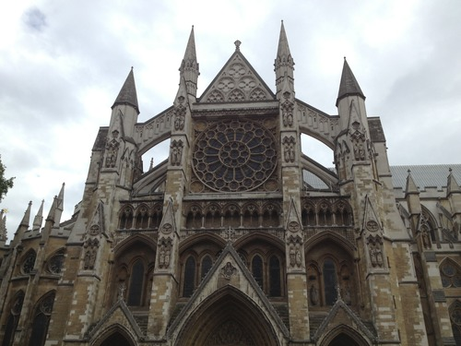
Sunday, July 28th was my eleventh day in London with my writing and technology class. While I was well over my jetlag, I was weary from traveling and the effort it takes to constantly meet new people, so I set off alone to Westminster Abbey, searching for the graves of poets and the presence of God.
A trip alone to the Abbey sounded restorative. Church is a place I find peace and a long train ride alone sounded like it would do me some good as well. I hopped a train from Guilford to London and took the time to journal and reflect on my trip so far. An hour later, a tube ride brought me from Waterloo to Westminster.
I arrived at Westminster Abbey an hour before evensong and queued up in the rain outside of the front gate. Standing in front of me was a surly man from Maryland who perfectly embodied the word curmudgeon. I talked with him briefly about teaching, traveling, and music.
Eventually, a deacon came to retrieve the parishioners and we filed into the church behind him. I was amazed at the bigness of Westminster. On the way into the church, I made the mistake of snapping a picture, earning the stern admonishment of a priest with a lazy eye. He stepped in front of me, stopping the progress of all of the parishioners on their way to the pews. “No taking pictures in the abbey,” he croaked.
Embarrassed to be that tourist, I deleted the picture from my phone and hastily apologized. “I’m sorry. I was caught up in its beauty. I just wanted to remember it and wasn’t thinking,” I explained to my captor, with an apologetic smile, trying to step around him.
“If you’re here to take pictures, then you’ll need to leave.”
“I’m very sorry,” I repeated and finally I was allowed to continue up the aisle, by this time feeling quite unwelcome and somewhat disappointed in myself. My motivation for coming to the Abbey really wasn’t to take pictures and gawk like a tourist. I wanted to experience an evensong, pray, and find some peace. But really, would taking a picture prevent that? Did it warrant the inquiry into my presence there?
A visiting choir sang in between prayers, the Apostles’ Creed, and the reading of scripture. A chant of stand up, sit down, stand up, kneel. Stand up, sit down, don’t close you’re eyes while the choir sings or you’ll fall asleep! marched through my head.
The Reverend Stephen Ferns preached a sermon about how Jesus chose the twelve apostles. He had the most monotone voice I have ever heard, but I listened carefully and took notes in my daybook.
Reverend Ferns started off by mentioning the British version of the reality TV show the Apprentice, where the counterpart to Donald Trump is a man called Lord Sugar. Really, that’s his name. Watch the musical intro to the next season of the British Apprentice if you don’t believe me: http://www.bbc.co.uk/programmes/p0185zsg. His description of the show earned him a few chuckles from the congregation.
The reverend compared the process of finding a new apprentice to his own job of choosing priests for the church. What qualifications, therefore, should he look for in a priest? He has to consider risk and potential. For that matter, what did Jesus consider when choosing the twelve? Would that provide some formula to follow?
“Think about the twelve,” he urged. “Simon was a violent zealot. Levi a thug (AKA tax collector,) James and John were the SONS OF THUNDER, and Peter was emotionally unstable enough to chop off a man’s ear. So why did Jesus choose these people?” It was blatantly obvious that the people Jesus chose to be his apostles are the people who generally wouldn’t feel accepted in one of today’s churches, and I waited for the reverend to say something to that effect, but he didn’t go there.
Reverend Ferns ended his sermon by reminding the congregation that we are all called to be “apprentices” and we should be risk-takers, but he didn’t actually go into what that looks like or what it might mean in actual day-to-day life and what the role of “so called outcasts” in the church might be. I was disappointed. Where was the encouragement to go and find the tax collectors, the thugs, the emotionally unstable, the outcasts of our generation? (Ahem, what about the silly tourists who mistakenly take pictures when they oughtn’t?) Where was the point that we're all messed up in some way but it doesn't matter because Jesus loves the outcast and sacrificed his life for our sake? Why set up the thought and then dismiss it before actually making your point?
I loved the tradition of the service. The music was beautiful. The Lord’s Prayer and the Apostles’ Creed were familiar to me. But in this majestic place, I couldn’t help but think that Westminster was more of a living museum that it was about a relationship with God, that the church was the building and not the people. I was treated not like a sister in Christ, but a tourist. It seems harsh to write these things. After all, Westminister is a tourist destination, even though it’s a church. Hadn’t I even treated it as such, snapping a picture on the way in?

